Ideation Phase
Brainstorm & Idea Prioritization Template
Date | 15 Feb 2026
Team ID | LTVIP2026TMIDS66286
Project Name | Gemini Pro Financial Decoder: Transforming Complex Data into Actionable Insights
Maximum Marks | 4 Marks

Project Overview
Gemini Pro Financial Decoder is an AI-powered system designed to analyze, interpret, and simplify complex financial data such as balance sheets, income statements, cash flow reports, and market data. The system leverages advanced large language models (Gemini Pro) combined with financial analytics to convert raw numerical and textual financial information into clear summaries, visual insights, risk indicators, and actionable recommendations.
The primary goal of this project is to support financial analysts, business owners, investors, and non-finance professionals by reducing manual analysis effort, minimizing errors, and enabling faster, data-driven financial decision-making.

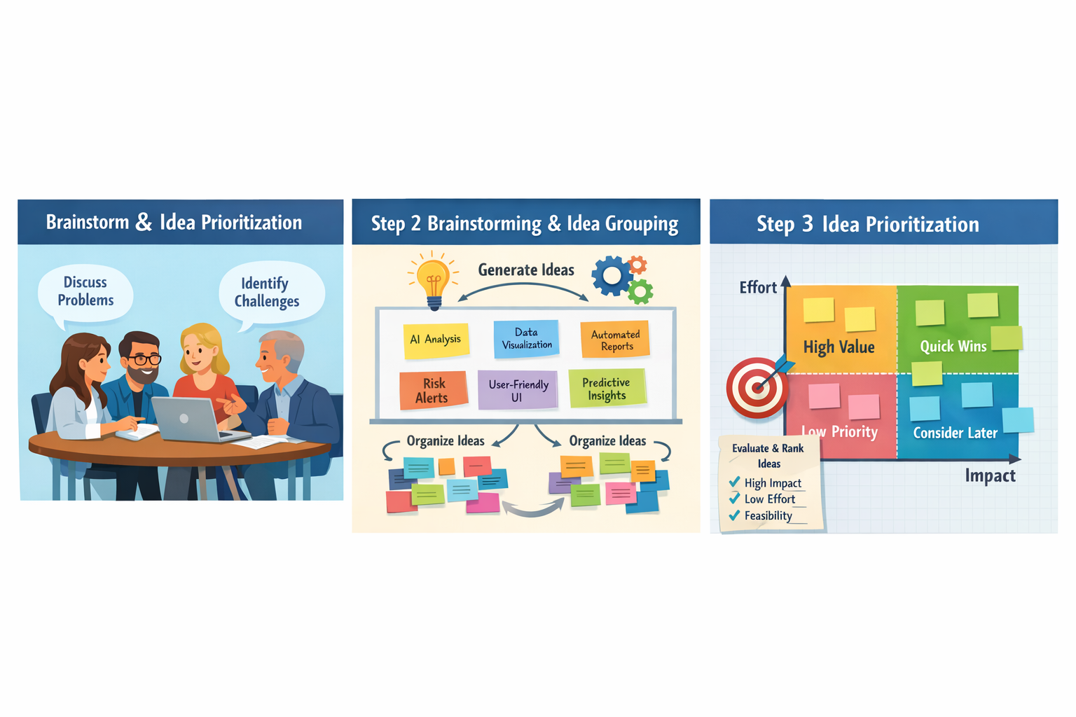

Step-1: Team Gathering, Collaboration & Problem Statement Selection
The team collaboratively discussed challenges faced by users while interpreting financial data. Based on empathy mapping and problem definition, the selected problem statement focuses on the difficulty of understanding complex financial reports and extracting actionable insights in a time-efficient manner.
Step-2: Brainstorming, Idea Listing & Grouping
Idea List:
- AI-based financial report summarization
- Automatic extraction of key financial metrics
- Risk and anomaly detection in financial statements
- Visual dashboards for trends and performance
- Natural language explanations for financial terms
- Predictive insights for future financial performance
- Question-answering system for financial documents
Idea Grouping:
- Data Understanding: Summarization, metric extraction, financial term explanation
- Analysis & Intelligence: Risk detection, anomaly identification, trend analysis
- User Interaction: Interactive dashboards, conversational Q&A interface
Step-3: Idea Prioritization
Based on feasibility, user impact, and relevance, the following ideas were prioritized:
- Automated financial report summarization using Gemini Pro
- Intelligent risk and trend analysis
- Simple natural language explanations for complex financial data
- Interactive visual dashboard for insights

